HOW TO ACCESS YOUR ONLINE TRAINING
United K9 Search Training Center
Follow these steps to create your account, join your assigned class, and open the course materials.
Have your class access code ready before you begin.
STEP 1 | OPEN THE TRAINING CENTER
From the United K9 Search Training Center home page, click the portal that best fits you. You will enter the training through the portal.
STEP 2 | CREATE OR SIGN IN TO YOUR ACCOUNT
Log in with your Google account. If you do not have a Google account, click the Sign In button at the bottom of the screen and follow the prompts to sign in or create your account.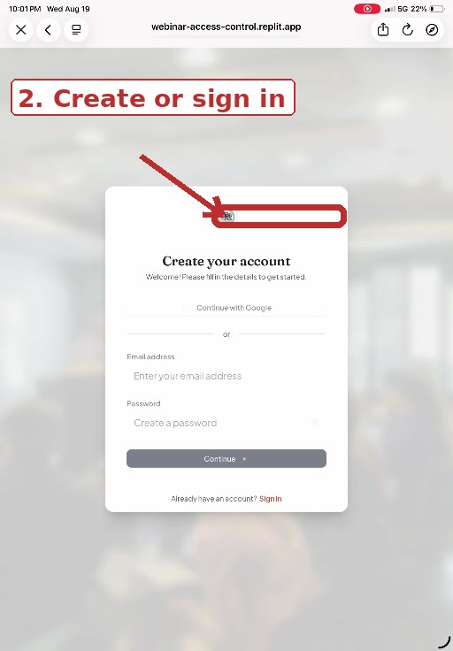

STEP 3 | GO TO JOIN A CLASS
After signing in, you will arrive at My Classes. Select Enter Access Code or Join a Class.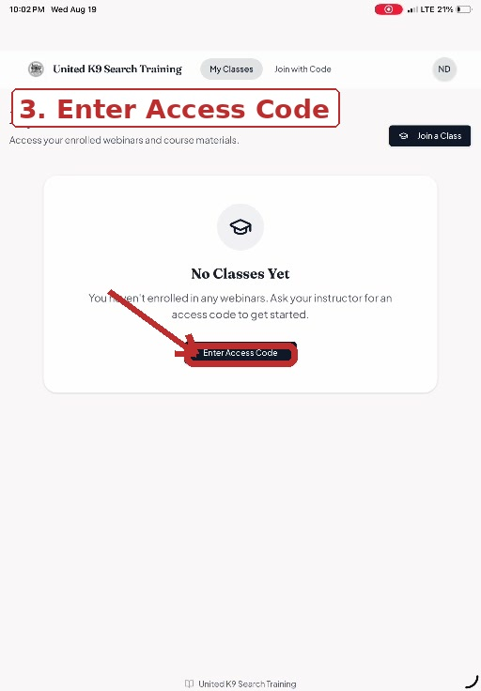
STEP 4 | ENTER YOUR CLASS ACCESS CODE
Type the access code provided by your instructor, then select Verify Code. Access codes are class-specific, so enter the code exactly as provided.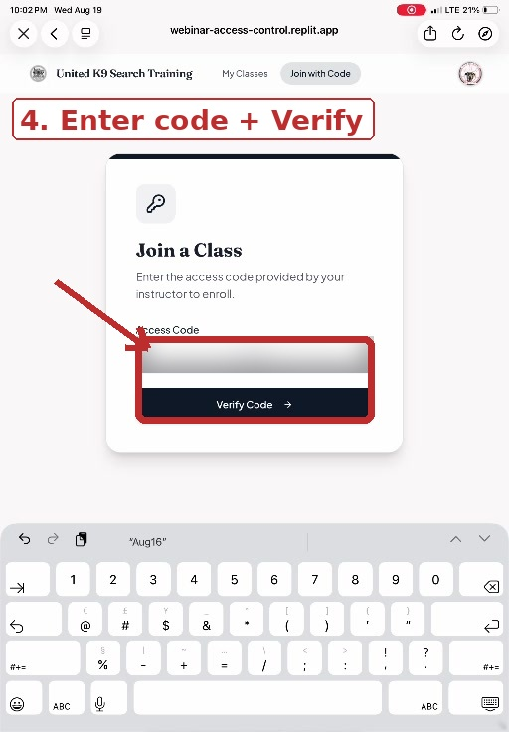

STEP 5 | COMPLETE REGISTRATION
When the correct class appears, enter your first name, last name, and email address. Review the information, then select Enroll in Class.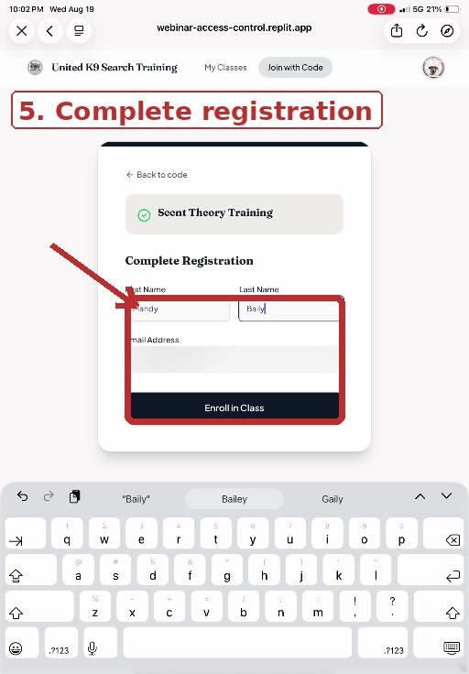

6. View or Download the Slides
Use the top arrow to download the slide presentation, or use the bottom arrow to click through and view the slides.
Your enrolled course will appear under My Classes. Open the course to view the training material. Use the on-screen arrows to move forward or backward through the presentation.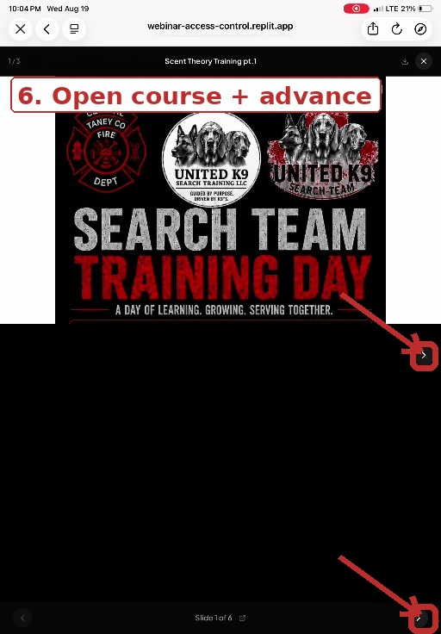
RETURNING STUDENTS
Once enrolled, you do not need to enter the access code again for that class. Sign in and select My Classes / My Training to return to your course materials.
Guided by Purpose. Driven by K9’s.

QUICK ACCESS & COURSE UPDATES
Add United K9 Online Training to Your Home Screen
If you would like quick access to the training portal and updates about new material added to the webinars, add the app to your Home Screen.
1. Click the Share button while you are on the United K9 Online Training page.
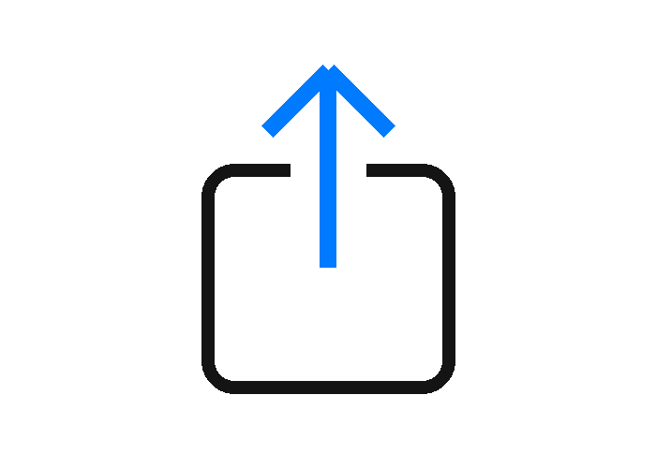
2. In the Share menu, scroll down and select Add to Home Screen.
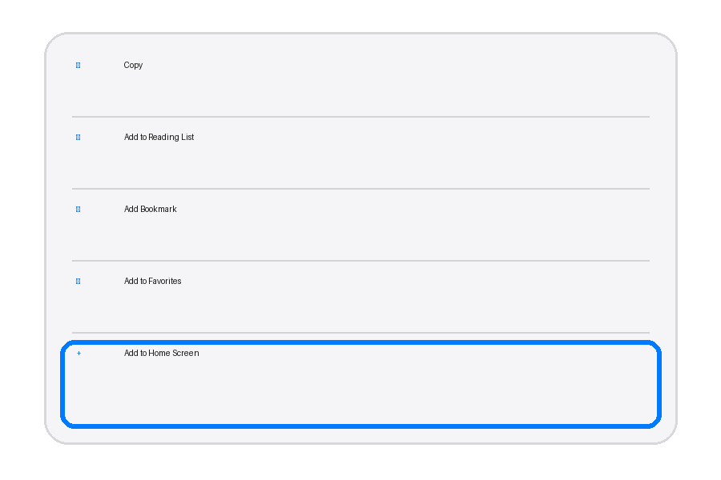
3. Tap Add. The United K9 Online Training app will then appear on your Home Screen for quick access.

